Exercise 2 Unit 1

Install Windows 10 in the virtual machine from exercise 1. You must add the following settings:

* + USB 3.0 support.
  + Shared folders.
  + Internet connection including access to the rest of computers of the network.
  + You will be able to copy and paste from the host to the guest and vice versa.
* We have to chose the correct ISO acording to the operating system we want, in this case Windows 10.

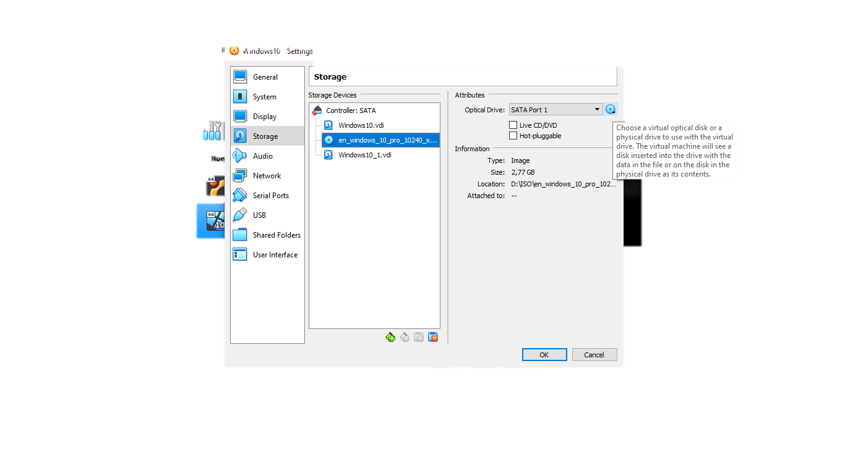

* After that we must change the network to bridge adapter

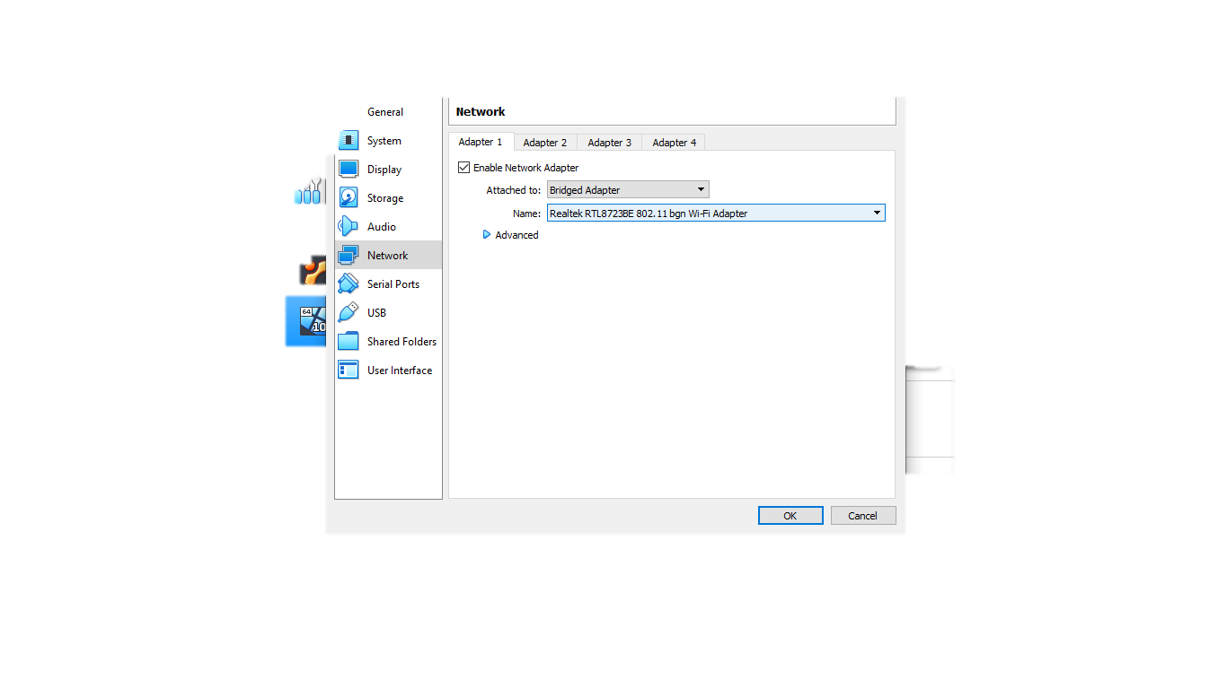

* When we finish with the settings of the virtual machine we have to start it and installing Windows, we chose the correct language (English in this case), and a very import part is to choose de correct keyboard.

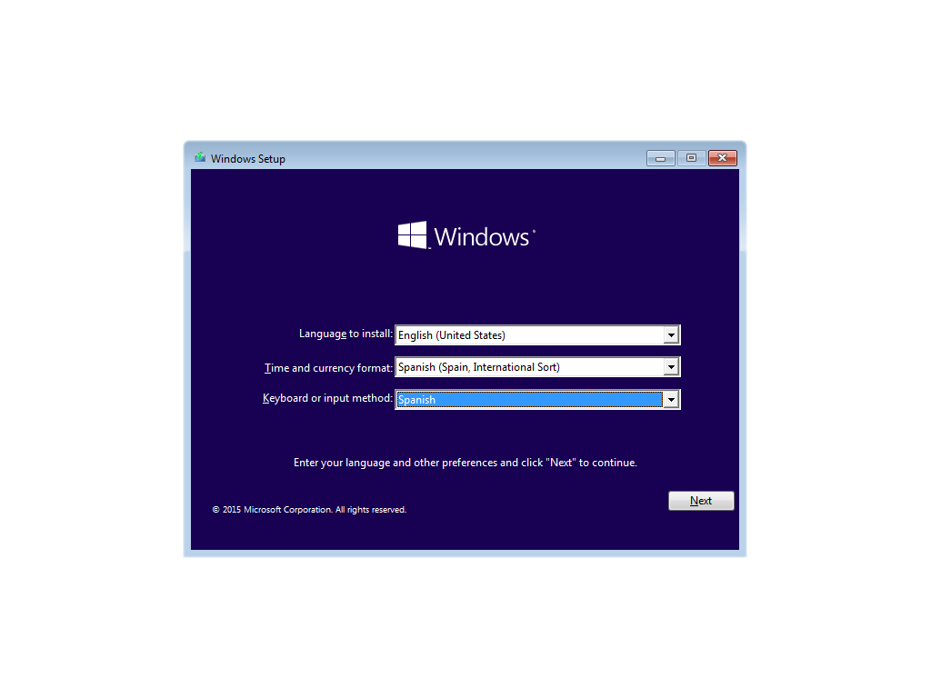

* The next step is start installing it.

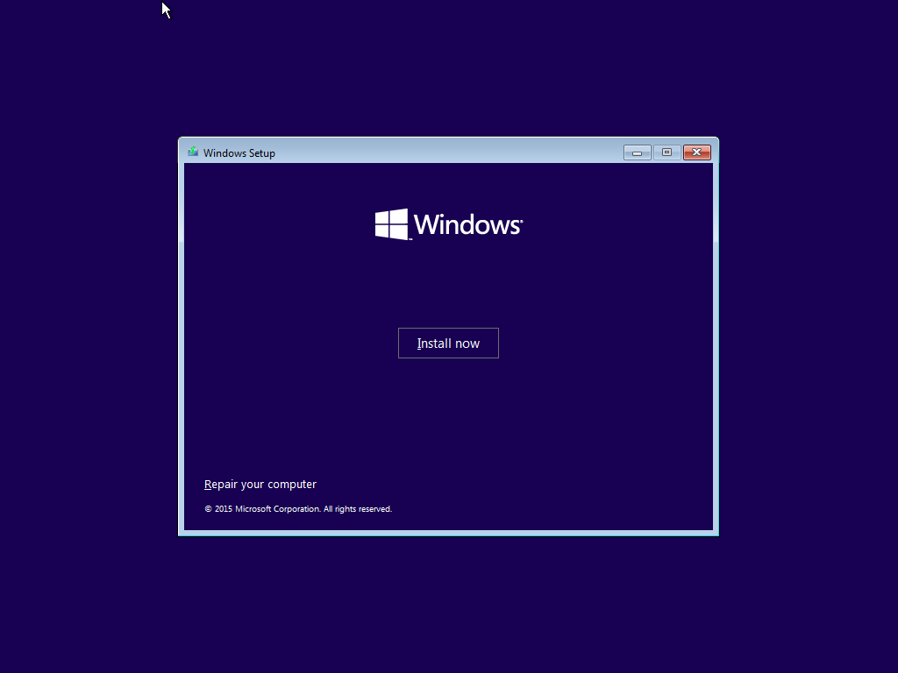

* After that we have to accept the license terms

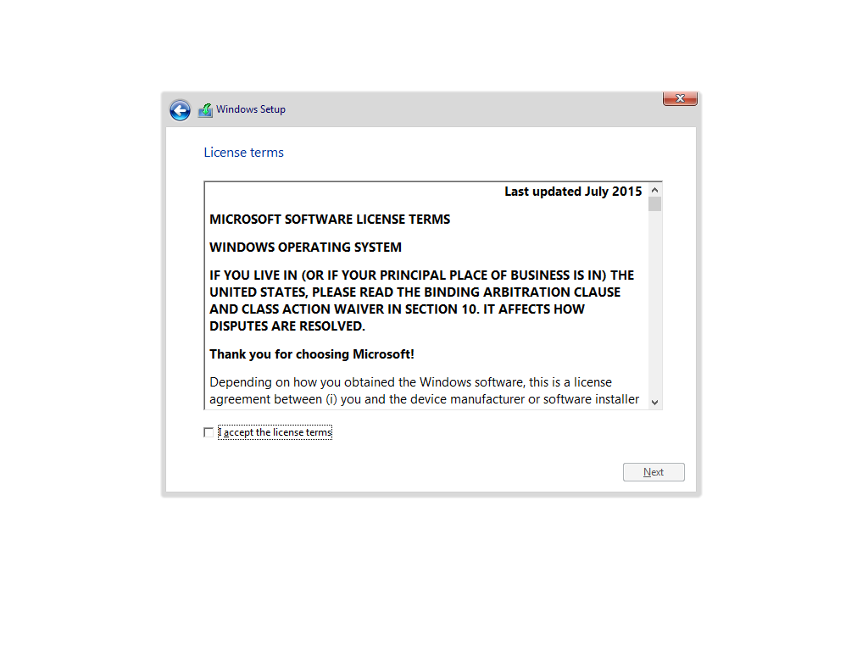

* When we press next it appears two options, upgrade or custom install.

We must choose the custom one because if we want to make partitions is the only way.

*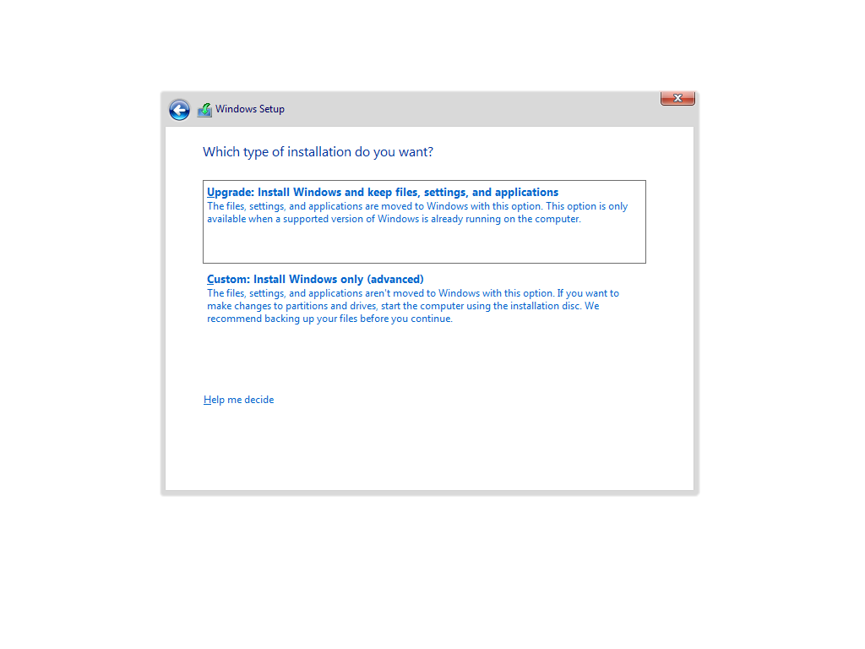*

* Then we can create a new partition for example of 12GB

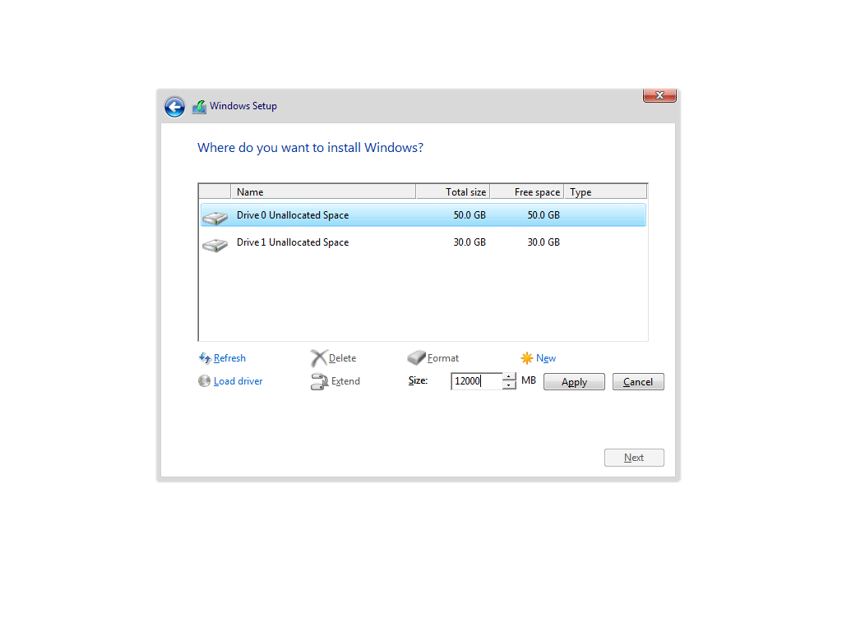

* When these steps are made, we can finally install Windows 10 in our virtual machine.

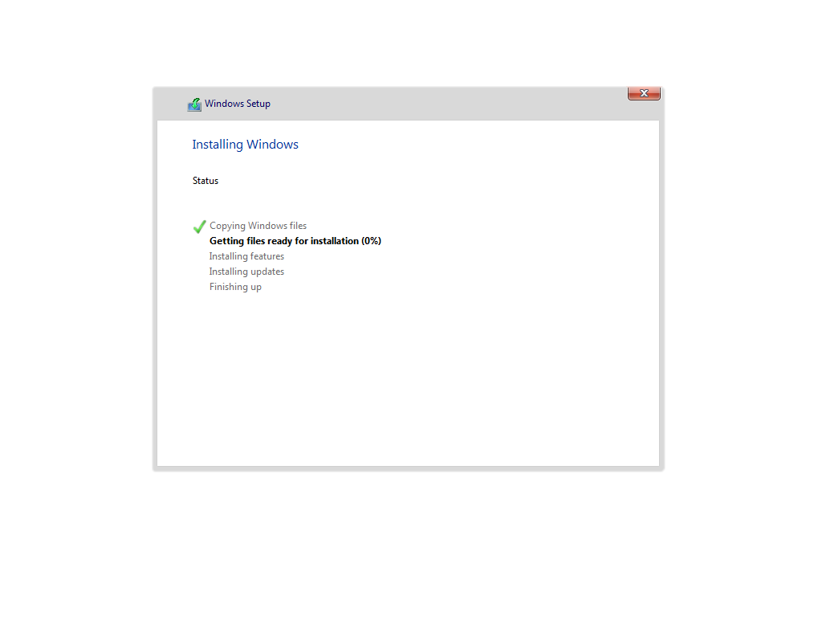

* Now we can use the Use Express Settings option.

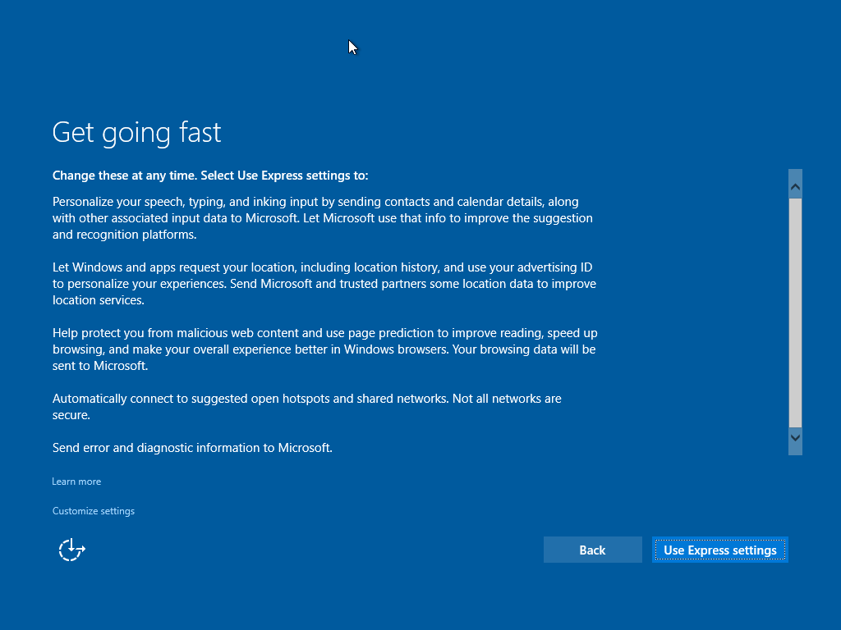

* When we finish this step, it would ask us for a name and a password.

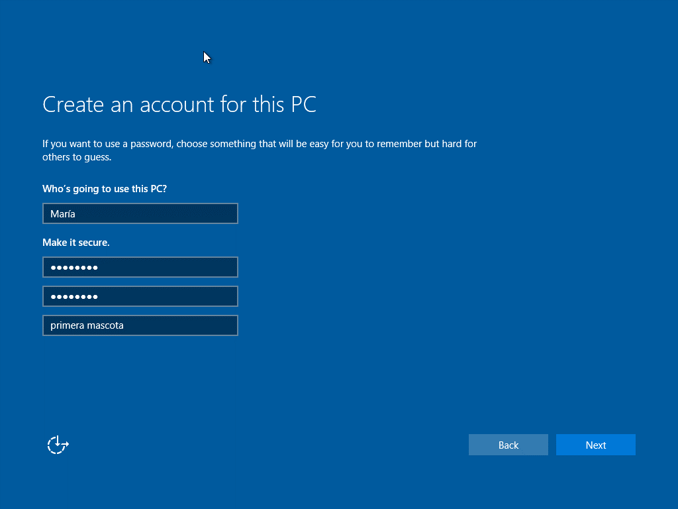

* Now according to the exercises, for the changes and things we have to do is necessary to click on the guest additions.

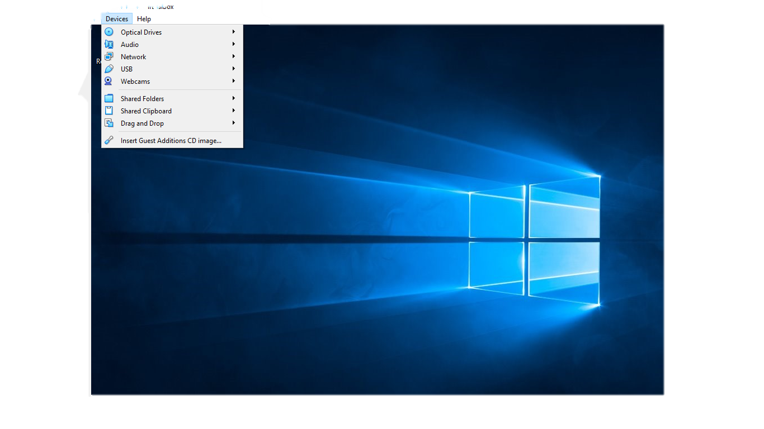

* In the general option in settings, we chose bidirectional.

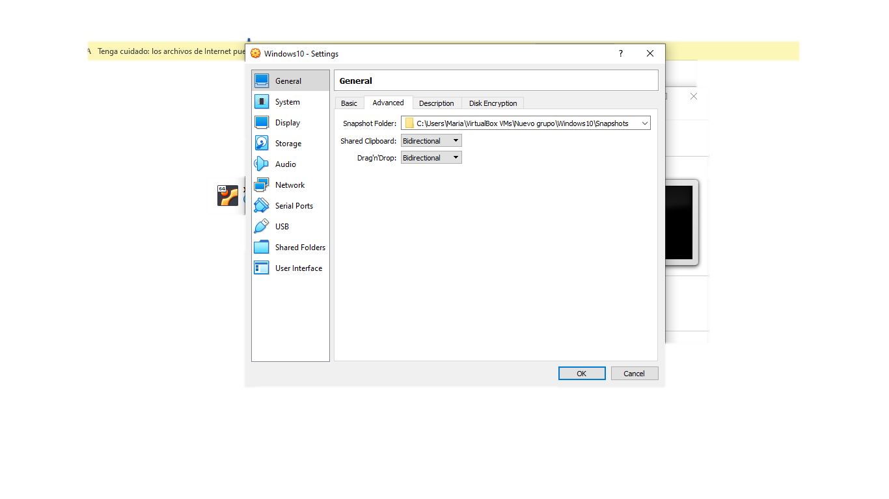

* For the option share folders, we can choose the Auto-mount, doing this we don´t have to configure anything else.

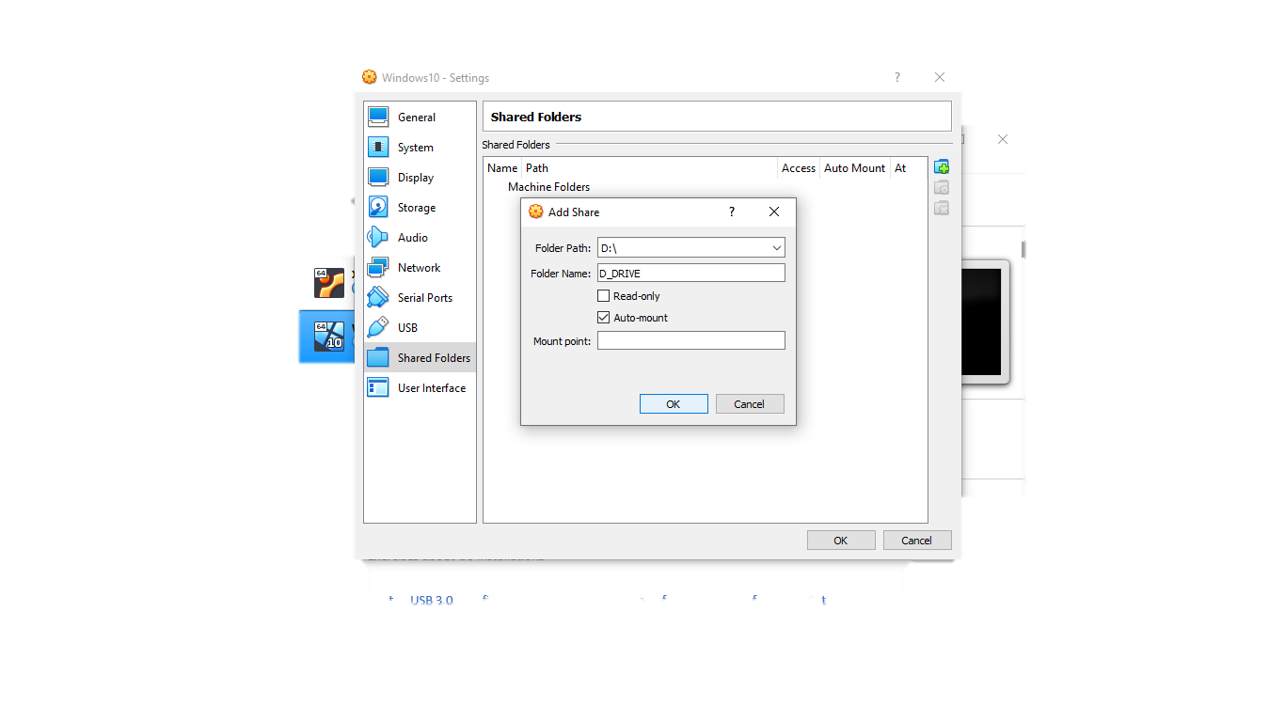

* Last thing we have to add is the 3.0 USB, for this is necessary to have install the VirtualBox extensions.

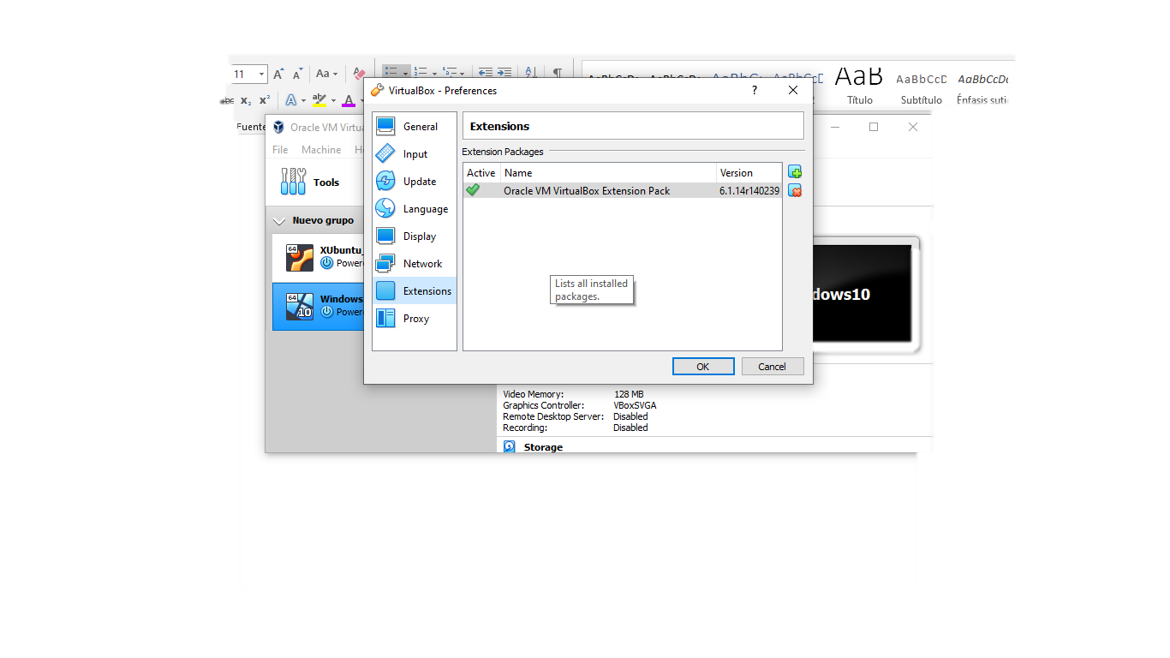

* Finally, we can choose the USB we want

